PATH PLANNING AND OBSTACLE AVOIDANCE OF A 2-D TERRESTRIAL SWARM ROBOTIC SYSTEM

This report is submitted for requirements pertaining to PG Seminar for Second Semester

MASTERS IN CONTROL SYSTEMS ENGINEERING

Submitted by
Arijit Kumar Haldar
MCSE, 1st Year, 2nd Semester
Roll Number: 002010804015

Department of Electrical Engineering
JADAVPUR UNIVERSITY
KOLKATA-700032

August, 2021
CONTENTS

Chapter 1: Introduction

  - Introduction 1
  - Brief recap from previous semester 1
  - Topics covered in previous semester 2
  - Topics covered in current semester 2

Chapter 2: Literature Survey
  - Robot path planning
    - Methods of single robot path planning 4
    - Problem reconsideration taking multi-robot approach 6
    - Discussion of methods mentioned in base paper 6
  - Swarm Formation
    - Separation 9
    - Alignment 10
    - Cohesion 10
  - Attraction-Repulsion function in a swarm 11
  - Obstacle and goal considerations 13

Chapter 3: Problem Identification
  - Conditions to be met by the Swarm System 15
  - Mathematical Modelling
    - Swarm Modelling 16
    - Environment Modelling 17
Chapter 4: Simulation and Results 19
Chapter 5: Conclusion
5.1 Progress made so far 20
5.2 Scope of future work 20

References 21

Annexure 23
CHAPTER 1
Introduction
  - Introduction
Swarm is a behaviour exhibited by an aggregation having a collective motion. Swarm robotics, in essence, is a means to mimic and harness the usefulness of natural swarms, though not limited to its approach. Swam can be virtual, for example, a software swarm containing individual modules [10].
Swarm Robotic system uses individual robots or agents, that are relatively weak or inefficient in comparison to the task [10]. The individual agents work cooperatively, towards a common aim, to fulfil the aim.
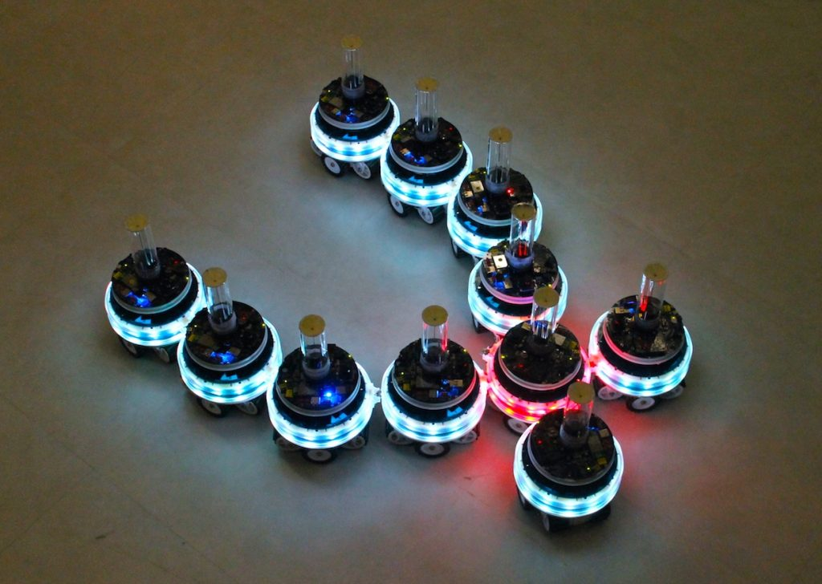
Fig 1: Example of a Swarm Robotic System [17]
  - Brief Recap from Previous Semester
The work done on this semester is continuation from the seminar topic of the previous semester. According to the proposal submitted by me, I covered a bird’s-eye-view of the topic on the previous semester, where I spent time to get acquainted with the problem and the various methods that are being implemented to address the issues in the papers that I referenced.
Literature survey was mainly done in the last semester, while understanding and discussing the mathematical models mentioned in the reference papers were covered on this current semester.
  - Topics covered in previous semester
Swarm formation, obstacle avoidance and path planning make up the basic control strategy of a swarm robotic system. In this regard, my seminar report for the previous semester on this topic covered the following aspects.
- Swarm robotics defines the field of robotics that deals with formation of flock or cluster of individual agents (robots) to carry out a specific mission or goal that is either incapable or inefficient to be carried out by a single robot of the same or different type [10].
- Literature survey including theoretical definition, discussion and aspects of mimicking biological agents such as animals, birds, fishes, insects etc [10].
- Leader-Follower implementation in a swarm for path planning in a 2-dimensional environment [4].
- Brief discussion on Particle Swarm Optimisation [13].
  - Topics covered in current semester

- Discussion on single robot path planning methods like Bug-1, Bug-2, Bug-tangent, etc.
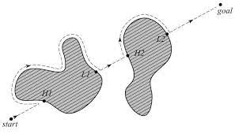
Fig 2: Example of a Bug Algorithm [16]

- Environment modelling using artificial potential function [11] to have a definite goal and obstacle coordinates.
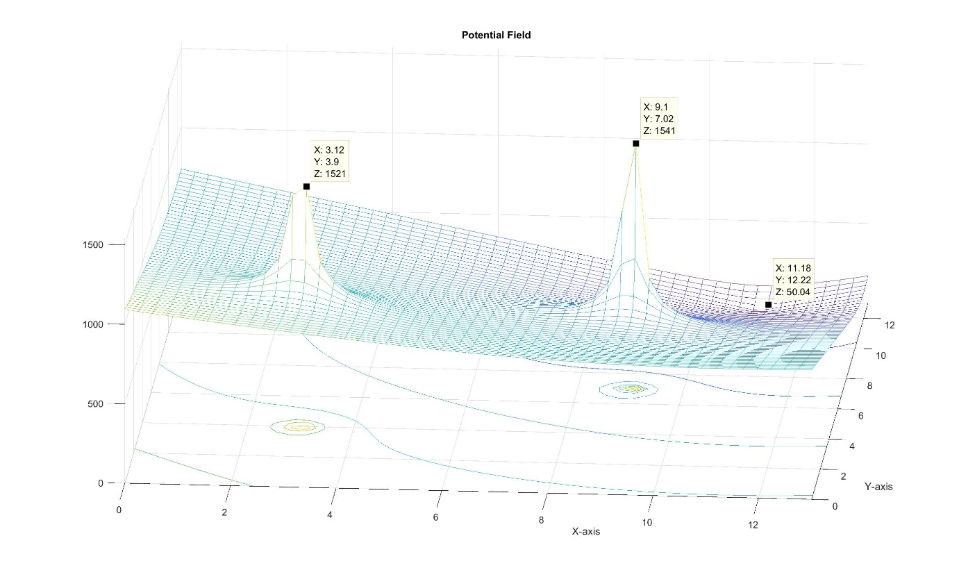
Fig 3: Visualization of Artificial Potential Fields using MATLAB
- Discussion on the attraction and repulsion function and its working in the given context in my reference papers.
- Discussion on components of control input required for swarm formation and maintenance during actuation.
- Environment modelling including obstacle coordinate modelling and method of reaching goal using negative gradient of resource profile.
- Simulation and validation of equations using MATLAB.

CHAPTER 2
Literature Survey

2.1 Robot path planning
Path planning for a single robot or multiple-robot system is of vital importance for carrying out any desirable mission for the system. Path planning may include the trajectory planning for the motion of the robot to reach a desired coordinate or the trajectory to be followed by a portion of a robot (for example a robotic arm).
2.1.1 Methods of single robot path planning
- For path planning of a single robot, the only required control actions needed are to move from any starting coordinate to the goal coordinate while avoiding the obstacles in its path.
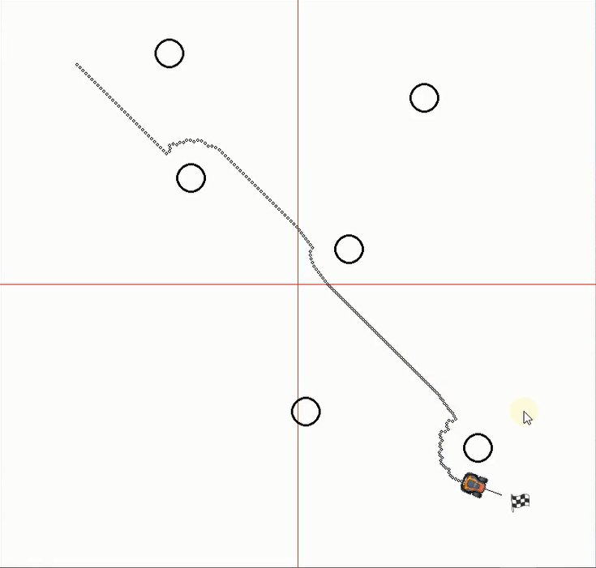
Fig 4: Screenshot from a simulation of single robot path planning using Python
- For this, a simple control algorithm, known as bug algorithm can be implemented. This is a basic control strategy where the goal coordinate is taken as a global minima, and the robot moves from the present coordinate towards the goal coordinate following the direct line of sight [16].
- If any obstacle is encountered in the line of sight, then the obstacle is avoided using one of the many bug algorithms.
- In Bug-1 algorithm, the robot follows the obstacle’s edge and circles around it while calculating the distance between that instantaneous edge coordinate and the goal coordinate. As soon as the shortest distance is found, the robot leaves the edge of the obstacle and follows the line of sight from that coordinate to the goal coordinate to reach the goal [16].
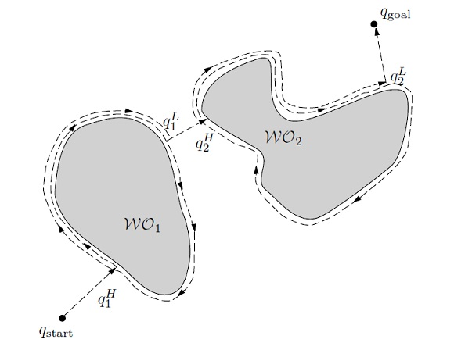
Fig 5: Demonstration of Bug-1 Algorithm [16]
- In Bug-2 algorithm, the robot leaves the edge-following state as soon as it encounters the next point of intersection of straight line between the beginning coordinate to the goal coordinate and the edge of the obstacle [16].
Fig 6: Demonstration of Bug-2 Algorithm [16]
- In Bug-tangent algorithm, the robot leaves edge following as soon as the robot can “see” or get a line-of-sight with the goal coordinate. The robot follows the tangent from the edge of the obstacle to reach its goal in this case [16].
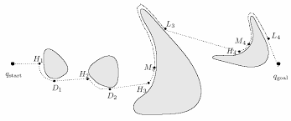
Fig 7: Demonstration of Tangent-Bug Algorithm [16]
2.1.2 Problem reconsideration taking multi-robot approach
- In multi-robot swarm, swarm formation, maintenance and proper swarm actuation needs to be taken into consideration. For this, separation, alignment and cohesion ensure a simple flocking action.
- In other words, all agents, no matter how far they are from each other, should attract each other so that as time progresses, all agents can congregate together.
- Also, as agents come close together, the agents shouldn’t collide or bump against each other. So, a repulsive action at close distances should be present, that prevents inter-agent collision.
- Now, to reach the goal, following negative gradient of the resource profile, the agents also have to avoid obstacles, which can be ensured by modelling goal coordinates as regions of maxima, which would automatically be avoided while following a negative gradient for path planning.
2.1.3 Discussion of methods mentioned in base paper
In the base paper(s) that I followed the method used to implement the steps mentioned in section 2.1.2 are:
- Swarm Modelling –
  - Introducing variables to define agent states [1]:

i {1,2,…,N}
: Position of i th agent
: Velocity of i th agent
: Mass of i th agent
: Control input of i th agent
N : Total number of agents in the swarm

It is to be mentioned here, that doesn’t denote the cartesian x-coordinate of the i-th agent; rather, it is a variable denoting the position coordinates of the i-th agent having both x and y components of the coordinate.

  - Attraction Function [1]

which ensures cohesion of the agents.
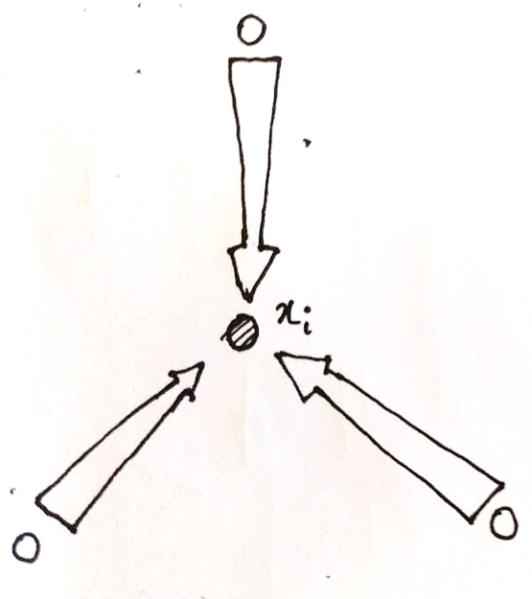
Fig 8: Drawing depicting change in magnitude of attraction function with distance

  - Repulsion Function [1]

which prevents inter-agent collision.
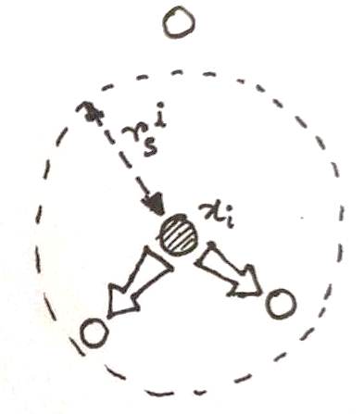
Fig 9: Drawing depicting change in magnitude of repulsion function with distance

  - Formation Control [1]

- Environment Modelling –
  - Defining the resource profile [1]:
The area in which the swarm travels to reach the goal coordinate from any originating coordinate is the resource profile.
It is called as a resource profile, because it mimics how insects such as ants use pheromone trails to reach the location of food. Similarly, in this case, following the negative gradient of the resource profile, the agents can reach the goal coordinate (assuming goal coordinate has global minima).

The above equation defines the chosen equation for resource profile on my reference paper, which is essentially a 2D sphere function with global minima at .

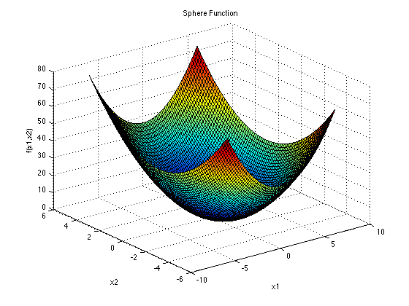
Fig 10: Plot depicting 2D sphere function with global minima at (0,0)

  - Defining Obstacle function [1]:

where, n = number of obstacles
= position of obstacle
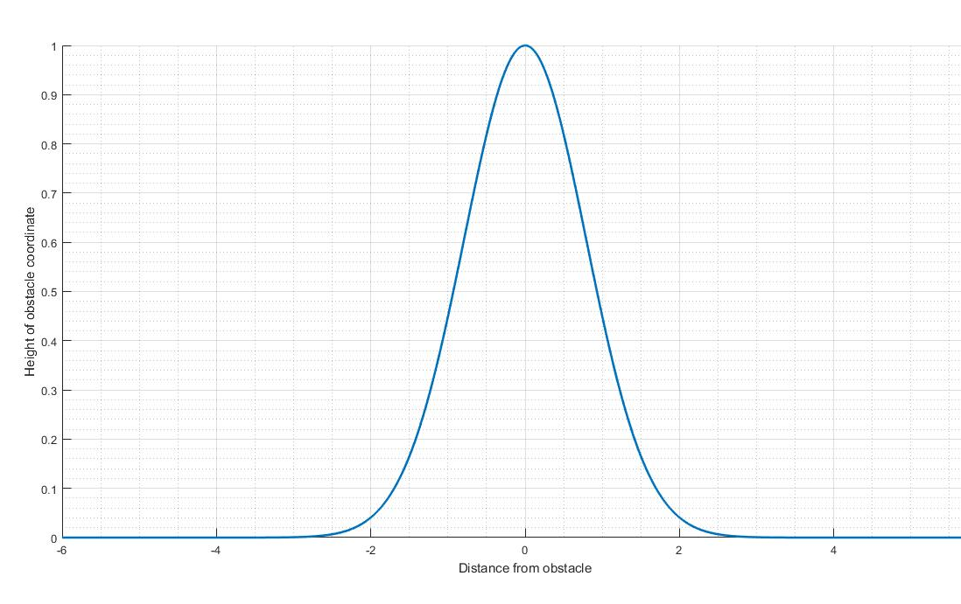
Fig 11: Plot depicting an obstacle using Gaussian function of unit height
2.2 Swarm formation
The swarm system, that is considered here, has a very simple goal to attain. It has to start from any arbitrary coordinates in the resource profile, form and maintain flocking, avoid obstacles in its path, and reach a pre-determined goal coordinate.

Now, for flocking to take place, we can use 3 simple rules:
2.2.1 Separation
A swarm robotic system is made up of multiple individual agents. While actuation, it is assumed that all those agents move together without colliding with each other. But, formation of a swarm requires agents to congregate together. So, a repulsive interaction at close distances is required which is inversely proportional to the distance of separation between two agents.
This control action is termed as separation, which prevents inter-agent collision [6].
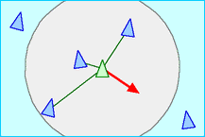
Fig 12: Visualisation of separation of agents [18]
2.2.2 Alignment
When considering physical robots as agents in the swarm, every robot has a defined “head” or forward direction for movement. This can be visualised with a velocity vector pointing towards the direction of forward motion.
Now, for maintaining swarm cohesion during actuation, we require all agents to move together, in the same direction. This can be achieved by making each agent’s velocity vector to point towards the average heading direction of the other agents. In this way, as time progresses, all agents will get aligned in the same direction, and not lose flocking during actuation [6].
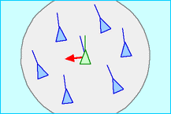
Fig 13: Visualisation of alignment of agents [18]

2.2.3 Cohesion
Cohesion defines the binding together of swarm agents. From alignment, we can get the velocity vectors to align together. But separation and obstacle avoidance are repulsive in nature, so, we need an inter-agent attraction in our control algorithm to maintain flocking. This can be achieved with cohesion.
Cohesion is achieved by defining an attraction function, that is applicable on all agents in the swarm. For any agent at any arbitrary position x, it attracts all the other agents towards itself with a magnitude of force directly proportional to the distance of separation between the agents. This allows all agents to flock together as time progresses during actuation [6].
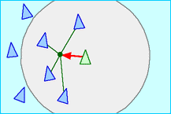
Fig 14: Visualisation of cohesion of agents [18]
2.3 Attraction-Repulsion function in a swarm
Attraction-Repulsion theory is the way to impart finite sense ability into swarm systems. The swarm starts with an aggregation with random position and velocity vectors, but the agents converge to a bounded ball or circle around the swarm centre in finite time.
The mathematical definition of this can be defined as follows:
Let us consider a swarm with N number of agents in an n-dimensional space. If the agents are modelled as individual points, then the control input required for actuation of agent i can be given as-
Taking assumptions that all agents are taken as point-mass dynamics and they “know” their own dynamics. Also, defining position of any arbitrary i th agent as , the velocity as and mass as . The control input required for each agent to maintain the swarm is then given by [7].
So, i {1,2,…,N}
: Position of i th agent
: Velocity of i th agent
: Mass of i th agent
: Control input of i th agent
N : Total number of agents in the swarm
(1)
(2)

Attraction Function
(3)

is the strength of attraction experienced by the j th towards i th agent.
i ,j {1,2,…,N}; where N is the total number of agents.

Here, it is to be noted, that for every agent, as the distance between that agent and any other agent increases, the attraction function has a higher magnitude of attraction between the two agents. The attraction function is considered as a negative magnitude while repulsion is taken as positive magnitude; which is the sign convention chosen in my reference papers. The linearly proportional attraction function ensures cohesion of the agents [7].
Repulsion Function
(4)

is the strength of repulsion experienced by the j th agent from i th agent.
is the region of repulsion.

For the repulsion function, first a circle encompassing the agent under present consideration (i th) is made with a radius of . This defines the region of repulsion of the i th agent. Now, the repulsion interaction increases as distance between the i th and j th agent decreases. The squared interaction ensures repulsion from all directions, irrespective of sign convention chosen for the coordinates [7].
Since both the attraction and repulsion function are applicable at all coordinates the agent may be in, in the resource profile, so, the value of gains & determine at what distance which function’s magnitude will dominate. Since repulsion function has nearly zero magnitude outside the region of repulsion, so, the region where attraction and repulsion functions balance each other is close to the region of repulsion.
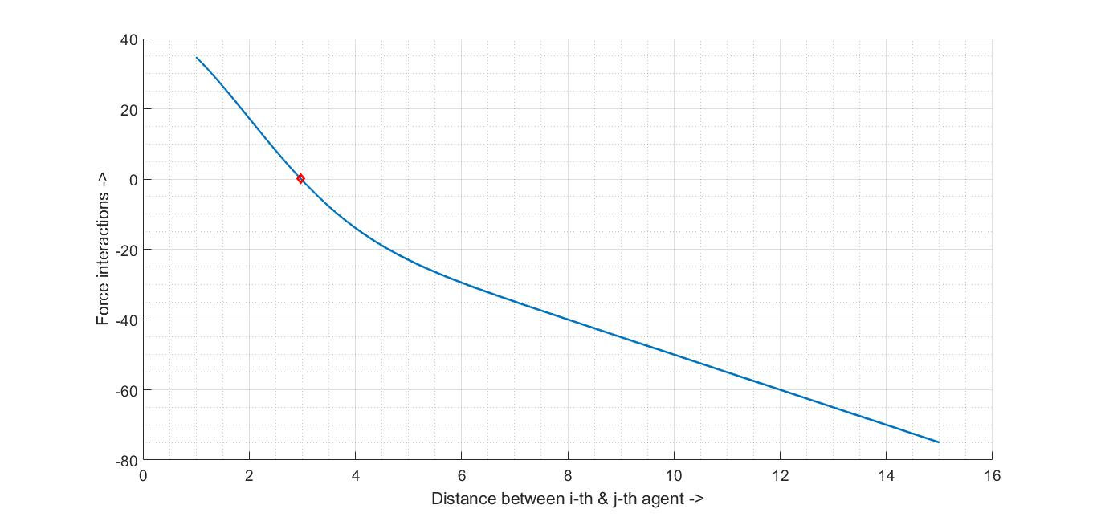
Fig 15: Plot depicting action of both attraction and repulsion forces with distance

  - Obstacle and Goal Consideration
Any object that hinders the path that is chosen by the negative gradient of the resource profile is considered as an obstacle for the swarm to reach its goal. Now, for obstacles and goal, it is imperative, that the obstacle avoidance and moving towards the goal during actuation is to be mathematically realisable. For this, the goal is considered such that the resource profile is warped to have the coordinate of the goal as the global minima, while the obstacles are such that the coordinates are described by gaussian functions of unit height [1].
Resource Profile:
(5)

Obstacle Function:
(6)

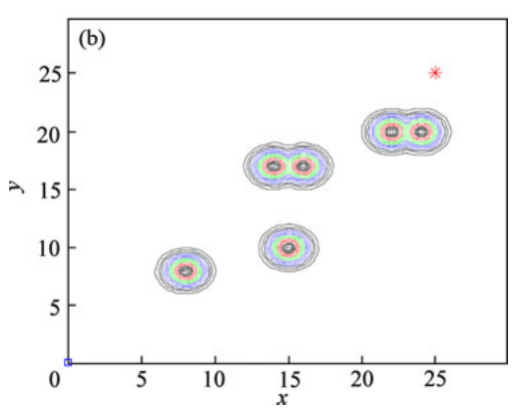
Fig 16: Plot depicting multiple obstacles on resource profile
where, denotes position of the goal coordinate, the position in consideration at present instant and is the position of the i th obstacle.
It is to be noted here, that taking max of the obstacle function ensures that during computation around any particular obstacle, the resource profile is not affected by the other obstacles. Thus, this ensures that all obstacles are independent of each other [1].

CHAPTER 3
Problem Identification
In the context of the problem being discussed, the goal or mission of the swarm robotic system is to start from any arbitrary point in the resource profile, form and maintain a stable swarm, and traverse through the resource profile, following the negative gradient of the resource profile to reach the target coordinate, while avoiding obstacles in its path.
Now, for the swarm system, the following conditions has to be met –
3.1 Conditions to be met by the Swarm System
- The swarm system should be such that no matter where the agents start from, after sometime, all agents should come together, i.e., they should have an attractive interaction between themselves.
- The swarm system should be able to repel other agents when they come too close to each other, i.e., they should have a repulsive interaction to avoid inter-agent collision.
- The agents in the swarm should be able to align with the average direction of all other agents and match the average velocity of the entire swarm, such that the swarm formation is maintained.
- The obstacles should be so designed that the agents have a repulsive interaction from the obstacles. This can be achieved by modelling the resource profile having region close to the obstacle coordinate to be in opposite sense to that of the region of the goal coordinate.
- Since the calculations are made assuming that the agents can calculate their position, velocity, etc., so, error in calculation of these values should be taken into consideration, for taking into account the error in sensing during minimization of Integral Squared Error (ISE) [1].
  - Mathematical Modelling
As discussed in section 2, for flocking action to take place, the swarm modelling should be such that each agent of the swarm would know their own and the other agent’s location, orientation and velocity. This would allow each agent to realise the motion dynamics that would be best suited for every step of iteration during actuation.
Now, for the swarm modelling, the desired condition is that all agents would come together as a swarm, while also avoiding inter-agent collision. For environment modelling, the desired condition is, that the swarm would maintain while actuation, and avoid obstacles while planning its path through the terrain or resource profile, and reach the goal coordinate.
3.2.1 Swarm Modelling
- Determination of velocity of each agent based on change in position

- Determination of control input

Here, it is to be noted that control input has dimension of force, which is, in turn a dimension of force and acceleration. Dividing that by mass gives a term that is dimensionally equivalent to acceleration. Thus, derivative of change of velocity is equal to . Now, will have both attractive and repulsive components, based on distance [7].
- Defining attraction function as function of distance

Attraction function is taken as negative in this sign convention.
- Defining repulsion function as a function of distance and radius of region of repulsion

Repulsion function is taken as positive in this sign convention. Repulsion function will have maximum value of magnitude when and decrease as the absolute value of difference in distance increases [7].

3.2.2 Environment Modelling
The environment being defined in the mathematical modelling is the area through which the agents are allowed to actuate. This is called as the resource profile, where, the target is the goal coordinate for all agents.
- Defining the resource profile as a 2-dimensional sphere function

In this context, the “resource” is being placed at , and thus it is the goal coordinate. Thus, the function warps the resource profile, such that coordinate is the global minima. Thus, following negative gradient of the resource profile allows reaching the goal coordinate from any arbitrary starting coordinate in the resource profile [1].

- Defining the obstacle function

In this context, is the pre-determined position of ith obstacle. The exponent function has maximum value at position . Thus, the max of obstacle function ensures, while warping the resource profile to take into consideration available known obstacles, gaussian function of unit height denotes the location of obstacles, while keeping each obstacle independent of each other, because of the fact that around close to , the immediately close obstacle would always yield max value due to shorter distance [1].
- Summing up the control actions in [1] –
taking,
(7)
(8)

sensing error in position relative to
sensing error in velocity relative to
(Assuming, each agent i can sense & relative to & )
(9)
agents actually sense,
(10)
(11)

Here, resource profile J(x) is defined based on Gaussian function ,
(12)
Then, is defined as [7]

CHAPTER 4
Simulation and Results

The MATLAB code, that I have provided in the Annexure section is a demonstration for visualising the control actions being discussed. The control actions used here are –
- Separation of agents from each other [6]
- Alignment of each agent towards average heading [6]
- Cohesion of agents together when aligned [6]
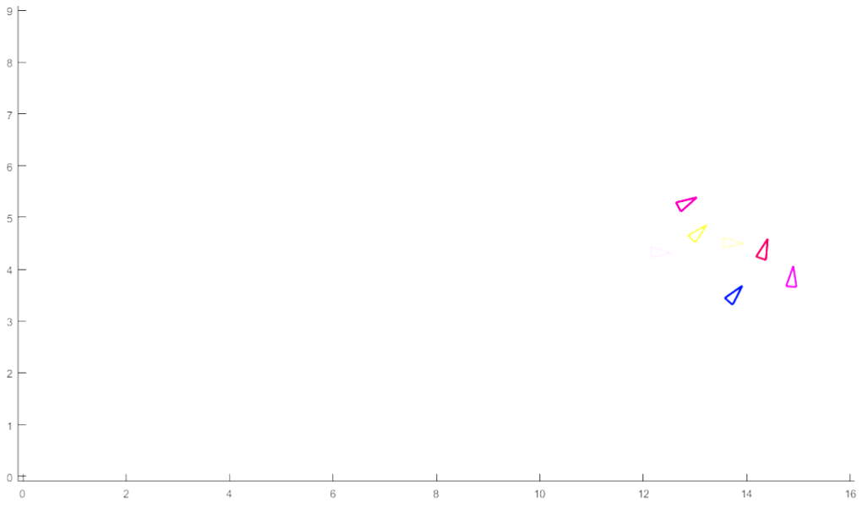
Fig 17: Screenshot of a time-instant demonstrating flocking
The simulation begins with any arbitrary “N” number of agents as user input. If the number of agents is too low, cohesion is not easily visible, so, the agents stay far apart due to separation.
Now, if we keep adding agents, the alignment and cohesion control rules become more visible, thus forming a flock.

CHAPTER 5
Conclusion
5.1 Progress made so far
- Books, journals and conference papers are discussed on the broad topic of Swarm Robotics to understand the basic principles.
- Few methods of swarming, path planning and obstacle avoidance has been chosen for detailed study.
- Particle Swarm Optimization and Leader Follower implementation has been studied and discussed during seminar.
- Swarming in artificial life-form “boids” interaction has been simulated for visualisation of flocking.
- Discussed on the mathematical modelling of the swarm system, its attraction and repulsion function, and thereby, formation of control input.
- Discussed on the mathematical modelling of the environment, comprising of the resource profile warping for the goal coordinate and the obstacle coordinates, to be able to follow a negative gradient of the profile for obstacle avoidance during path planning towards goal.
- Demonstrated a working of the swarm control rules, being discussed, using MATLAB.
5.2 Scope of future work
- Mathematical modelling was done based on the equations used in the reference papers I used. I understood and explained how the equations work in the given scenario, but why exactly those equations were used is still not perfectly clear to me.
- The goal of the swarm system chosen was to reach a pre-determined goal coordinate. The goal coordinate may not be pre-determinable, which would make the swarm system more robust.
- In case of multi-robot systems, formation control may be taken into consideration during actuation, if the mission benefits from it.

References
- D. Roy, M. Maitra and S. Bhattacharya, "Study of formation control and obstacle avoidance of swarm robots using evolutionary algorithms“, IEEE International Conference on Systems, Man, and Cybernetics (SMC), pp. 003154-003159, 2016.
- D. Roy, A. Chowdhury, M. Maitra and S. Bhattacharya, "Virtual Region Based Multi-robot Path Planning In An Unknown Occluded Environment“, IEEE/RSJ International Conference on Intelligent Robots and Systems (IROS), pp. 588-595, 2019.
- V. Gazi and K. M. Passino, "Stability analysis of social foraging swarms: combined effects of attractant/repellent profiles“, Proceedings of the 41st IEEE Conference on Decision and Control, vol. 3, pp. 2848-2853, 2002.
- V. Gazi and K. M. Passino, “Swarm stability and optimization”, Springer Science & Business Media, 2011.
- V. Gazi and K. M. Passino, "A Class Of Attractions/Repulsion Functions For Stable Swarm Aggregations“, International Journal of Control, vol. 77, issue 18, pp. 1567-1579, 2004.
- C. W. Reynolds, "Flocks, herds and schools: A distributed behavioral model“, Proceedings of the 14th annual conference on Computer graphics and interactive techniques, pp. 25-34. 1987.
- Y. Liu and K. M. Passino, "Stable social foraging swarms in a noisy environment“, IEEE Transactions on Automatic Control, vol. 49, no. 1, pp. 30-44, 2004.
- X. Liang, L. Li, J. Wu and H. Chen, "Mobile robot path planning based on adaptive bacterial foraging algorithm“, Journal of Central South University, vol. 20, no. 12, pp. 3391-3400, 2013.
- J. A. Oroko and G. N. Nyakoe, "Obstacle Avoidance and Path Planning Schemes for Autonomous Navigation of a Mobile Robot: A Review“, Proceedings of the 2012 Mechanical Engineering Conference on Sustainable Research and Innovation, vol. 4, pp. 314-318, 2012.
- H. Hamann, “Swarm Robotics: A Formal Approach”, 1st ed. Springer International Publications, 2018.
- M. C. Lee and M. G. Park, "Artificial Potential Field Based Path Planning For Mobile Robots Using A Virtual Obstacle Concept“, In Proceedings 2003 IEEE/ASME International Conference on Advanced Intelligent Mechatronics (AIM 2003), vol. 2, pp. 735-740. IEEE, 2003.
- D. Jayaraj, L. T. Vishwanath and O. V. S. Sarma "Path Planning In Swarm Robots Using Particle Swarm Optimization On Potential Fields“, International Journal of Computer Applications 60, no. 13, 2012.
- J. Kennedy and R. Eberhart, "Particle Swarm Optimization," Proceedings of ICNN'95 – International Conference on Neural Networks, Perth, WA, Australia, pp. 1942-1948 vol.4, 1995.
- Z. Hong, Y. Liu, Z. Gao, and C. Yi, "The Dynamic Path Planning Research For Mobile Robot Based On Artificial Potential Field“, In 2011 International Conference on Consumer Electronics, Communications and Networks (CECNet), pp. 2736-2739. IEEE, 2011.
- D. Bingham, “Sphere function with global minima”, https://www.sfu.ca/~ssurjano/spheref.png
- H.M. Choset, “Bug Algorithm”, http://webhost.bridgew.edu/jsantore/Teaching-Archive/Fall2017/Robotics/Navigation_bugAlgos.pdf
- “Swarmanoids,” https://spectrum.ieee.org/image/Mjk1MjUxNw.jpeg
- C. W. Reynolds, “The boids steering behaviour”, https://www.red3d.com/cwr/boids/

Annexure
MATLAB program used for simulation
function boids(numBoids)
global boids
global config
if nargin<1
config.numBoids = 0;
else
config.numBoids = numBoids;
end
config.area = [0 32 0 18];
config.area = [0 16 0 9];
config.max_speed = 0.3;
config.rule1 = 1;
config.rule2 = 1;
config.rule3 = 1;
config.invertRule1 = 0;
config.getTogether = 100 % rule 1 factor
config.minDistance = 0.5; % rule 2 factor
config.averageSpeedFactor = 200; % rule 3 factor the higher the smoother
config.execute = 1;
fig_handle = figure(1);
axis equal;
set(figure(fig_handle),'KeyPressFcn',@Key_Up); % interrupt when clicking fig

initialise_positions();

while(config.execute)
clf(1);
axis equal;
axis([config.area(1)-0.1 config.area(2)+0.1 config.area(3)-0.1 config.area(4)+0.1]);
hold on;
draw_boids();
move_all_boids_to_new_positions();
drawnow();
end

function initialise_positions()
global boids
global config
boids = [];
numBoids = config.numBoids;
if numBoids == 0
numBoids =input('Enter number of agents: ');
end
for it = 1:numBoids
xy = [config.area(1)+(config.area(2)-config.area(1))*rand()...
config.area(1)+(config.area(2)-config.area(1))*rand()];
u = [0.2*rand()-0.1 0.2*rand()-0.1];
theta = atan2(u(2),u(1));
boids(it).pose = [xy theta u]';
boids(it).color = rand(1,3);
end

function c = rule2(boidId)
global boids
global config
c = 0;
for it=1:size(boids,2)
if it~=boidId
if pdist([boids(it).pose(1:2)'; boids(boidId).pose(1:2)'],...
'euclidean')<config.minDistance
c = c-(boids(it).pose(1:2)-boids(boidId).pose(1:2));
end
end
end

function v3 = rule3(boidId)
global boids
global config
pvJ = [0 0]';
for it = 1:size(boids,2)
if it ~=boidId
pvJ = pvJ + boids(it).pose(4:5);
end
end
v3 = (pvJ-boids(boidId).pose(4:5))/config.averageSpeedFactor;

function move_all_boids_to_new_positions()
global boids
global config
area = config.area;
sumPos = sumAllPoses();
numBoids = size(boids,2);
for i = 1:numBoids
%%keepInsideArea
if boids(i).pose(1)>area(2)
boids(i).pose(1)=area(2);
end
if boids(i).pose(1)<area(1)
boids(i).pose(1)=area(1);
end
if boids(i).pose(2)>area(4)
boids(i).pose(2)=area(4);
end
if boids(i).pose(2)<area(3)
boids(i).pose(2)=area(3);
end

if config.rule1 && numBoids>2
v1 = ((sumPos-boids(i).pose(1:2))/(numBoids-1) - boids(i).pose(1:2))/config.getTogether;
else
v1 =[0 0]';
end
if config.invertRule1
v1 = -v1;
end
if config.rule2 && numBoids>2
v2 = rule2(i);
else
v2 =[0 0]';
end
if config.rule3 && numBoids>2
v3 = rule3(i);
else
v3 =[0 0]';
end
u = boids(i).pose(4:5) + v1 + v2 + v3;
if norm(u,2)>config.max_speed
u = u/norm(u,2)*config.max_speed;
end
end

function draw_boids()
global boids

for it= 1:size(boids,2)
x = boids(it).pose(1);
y = boids(it).pose(2);
theta = boids(it).pose(3);
XY = [-0.2 -0.1;...
-0.2 0.1;...
0.2 0; ...
-0.2 -0.1];
rotationArray = [cos(theta), -sin(theta);...
sin(theta), cos(theta)];
XY=rotationArray*XY';

% translate to desired center point
XY(1,:) = XY(1,:) + [x x x x];
XY(2,:) = XY(2,:) + [y y y y];
line(XY(1,:),XY(2,:),'Color',boids(it).color,'LineWidth',2);
end

function sumPos = sumAllPoses()
global boids
poses = [];
poses = [boids.pose];
sumPos = [sum(poses(1:2,:),2)];

function [] = Key_Up(src,evnt)
global config
key_value = evnt.Key;
disp('Press "q" to quit simulation');
switch key_value
case 'q'
config.execute = 0; %stop execution of the while loop
case '1'
config.rule1 = 1-config.rule1;
disp(strcat('rule1 = ',num2str(config.rule1)));
case '2'
config.rule2 = 1-config.rule2;
disp(strcat('rule2 = ',num2str(config.rule2)));
case '3'
config.rule3 = 1-config.rule3;
disp(strcat('rule3 = ',num2str(config.rule3)));
case '4'
config.invertRule1 = 1- config.invertRule1;
disp(strcat('InvertRule1 = ',num2str(config.invertRule1)));
otherwise
createBoid();

end

function createBoid()
global boids
global config
% create a new boid
newBoidPose = [ginput(1) 0]';
newBoidVel = [2*config.max_speed*rand()-config.max_speed 2*config.max_speed*rand()-config.max_speed]';
k = size(boids,2);
boids(k+1).pose = [newBoidPose; newBoidVel] ;
boids(k+1).color = rand(1,3);

